**DWH Deployment**

|  |
| --- |
| System test release  Date: 19/6/2017  Prepared by: Ian Meade |

**Pre-requisites**

* Deployment pack required
  + Includes:
    - TSQL scripts
    - SSIS deployment package
    - Sample folder structure
      * Sample files included
    - DWH backup
      * Based on Migration with data fixes
* Server is suitable
  + Refer to other document << XXXX >>
* SQL Agent Job has access to file folders etc…
* User has SA rights

**Deploy databases:**

* Using SSMS
* Open and run the following T_SQL scripts
  + 01 Create new DBs.sql
    - << Restore Backup XXXXX.BAK >>
    - Needs to stay – DDTs and SYS / production are not like for like

Edit .SQL

Search and Replace

‘C:\Program Files\Microsoft SQL Server\MSSQL13.MSSQLSERVER\MSSQL\DATA’

With

‘D:\SQLDATA’

19 occurrences

* + 02 DWH.sql
  + 03 MDM.sql
  + 04 ProcessControl.sql
  + 05 Staging.sql
  + 06 T7_ODS.sql
  + 07 XT_ODS.sql
  + 08 Reuters_ODS.sql
  + 09 StateStreet_ODS.sql
  + 10 Stoxx_ODS.sql
  + 11 ProcessControl Data.sql
  + 12 MDM Data.sql
* Restore the DWH backup to the DWH database *** Will apply at go live ***
  + Backup will be provided by Lar
  + Depends on deployment model used

**Deploy SSIS packages**

* Using windows explorer, double click on ETL.ispac file
* Integration Deployment Wizard will open
* Introduction page
  + Click next
* Select Source page
  + Accept defaults on this page
  + Click next
  + **Note:** Ignore the warning about XML encryption if it appears
* Select Destination
  + Server name: enter name of target server .
  + Path:
    - Use browse button to select target folder.
    - Create a new folder is required
    - Set value to /SSISDB/EQ1/ETL
      * << used during dev >>
  + Click next
* Review
  + Click Deploy
* Results
  + Click Close

**Configure connection strings**

* Using SSMS
* Open and run the following T_SQL scripts
  + 20 SSIS Configuration - T7-SYS-DW-01.sql
    - Needs to stay

Copy ‘SSIS Configuration – T7-DW-01.sql’ to ‘SSIS Configuration – T7-SQL-MIGRATE.sql’

Edit ‘SSIS Configuration – T7-SQL-MIGRATE.sql’

Search and Replace ‘T7-SYS-DW-01’ with ‘T7-SQL-MIGRATE’

10 Occurrences

* + 21 Assign parameters.sql
    - Do not run this step if the ETL has already been deployed to server
    - Need to spend more time on this step

Edit sql

Comment out as below, jobid does not exist on destination server

--EXEC msdb.dbo.sp_update_jobstep @job_id=N'5e323b15-5fb1-457b-86b6-4782f181f488', @step_id=1 ,

-- @command=N'/ISSERVER "\"\SSISDB\EQ1\ETL\PckMaster.dtsx\"" /SERVER "\"T7-DDT-06\"" /ENVREFERENCE 9 /Par "\"$ServerOption::LOGGING_LEVEL(Int16)\"";1 /Par "\"$ServerOption::SYNCHRONIZED(Boolean)\"";True /CALLERINFO SQLAGENT /REPORTING E'

--GO

**Note:**

This is a new step

This script varies for each target server - ensure the correct versions is used

Do not deploy agent jobs – create manually

**Create SQL Agent Jobs**

* Using SSMS
* Open and run the following T_SQL scripts
  + 10 AGENT JOB - Clear DWH.sql

Jobs are created manually – need to spend more time on this step

Delete Existing ‘Clear DWH’ Job

Edit ‘100 Clear DWH.sql’

Search and Replace ‘T7-DDT-06’ with ‘T7-SQL-MIGRATE’

1 Occurrence

Remove from script

USE T7_ODS

TRUNCATE TABLE [dbo].[PriceFile]

TRUNCATE TABLE [dbo].[TxSaft]

TRUNCATE TABLE [dbo].[File]

GO

USE ProcessControl

UPDATE XT_UpdateControl SET ExtractSequenceId = 0

TRUNCATE TABLE dbo.AlertLog

TRUNCATE TABLE dbo.ErrorLog

TRUNCATE TABLE dbo.ValidationLogMessage

TRUNCATE TABLE dbo.ValidationLog

TRUNCATE TABLE dbo.CanceledTradeManualList

TRUNCATE TABLE dbo.CanceledTradeReviewList

* + 11 AGENT JOB - Main ETL.sql
  + Should not be need if SSIS parameters are working correctly – need to spend more time on this step

Delete Existing ‘Main ETL’ job

Edit ‘99 Main ETL.sql’

Search and Replace ‘T7-DDT-06’ with ‘T7-SQL-MIGRATE’

3 Occurrences

Edit ‘Main ETL’ job

Select Environment

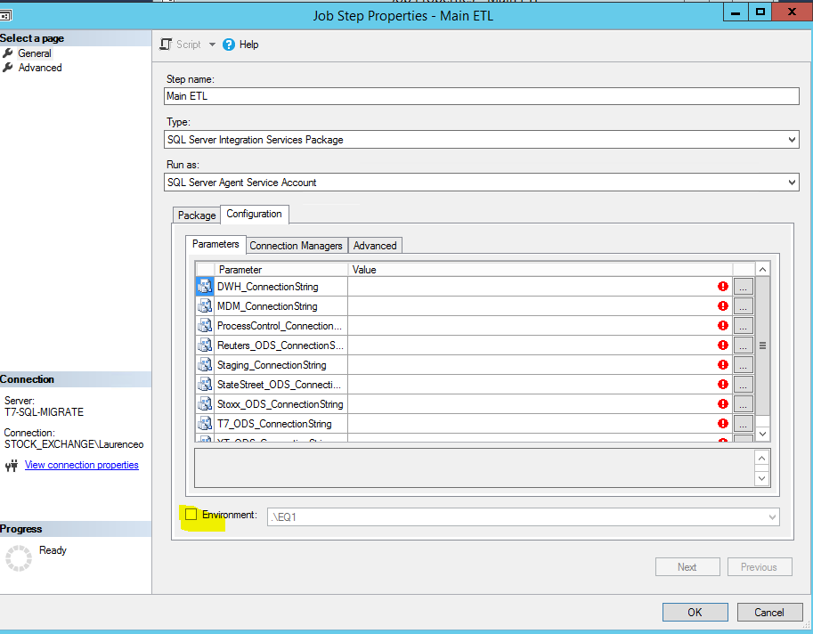

* + 12 AGENT JOB - MDM Refresh.sql *** No script provided ? ***
  + New job required
    - Reuters Index Load *** No Script Provided ? ***
* Review SQL Agent Service Account
  + Proxy / domain account needed
  + Using “ianm” in T7-DDT-06

**This is a new step**

**Resource file structure**

* Copy the Resource folder to “C:\DWH\” on the command server

**Source file structure**

* Ensure the input folder structure exists
  + This structure exists in the release folder.
* The following is used in dev
  + C:\dwh\Files\Archive
  + C:\dwh\Files\Process
  + C:\dwh\Files\Reject
  + C:\dwh\Files\Sample files
  + C:\dwh\Files\Source
  + C:\dwh\Files\Resource